Business Card

Font & Font logo Used:
Monseur ( Logo Font): https://elements.envato.com/monseur-futuristic-logo-font-FB5URH
Montserrat - https://www.fontsquirrel.com/fonts/montserrat
Open Sans - https://www.fontsquirrel.com/fonts/open-sans

Edit Smart Object
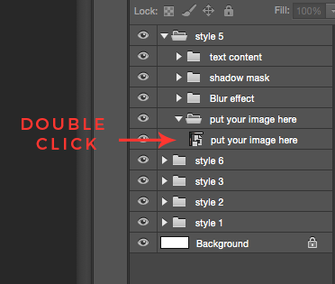
To edit the file just double click on smart object layer layer. it will open the smart object file
Paste your image and then click save ( ctrl + s / command + s )

Create Clipping Mask
Put your image above clipping mask layer right click - create clipping mask

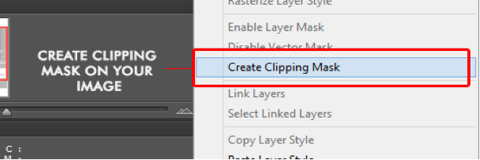

thanks for buying my item.

